5MERCORA INTERNATIONAL

Events & Engagements Gallery
Highlights of our workshops, conferences, partnerships and meetings, from July 2025 to October 2026.

2025
JULY 2025

Meeting with the Chairman, Telangana Backward Classes Commission
Mercora International Founder and Managing Partner Mrs. Jaya Geetha Kiran Desaraju had a meeting with Shri G. Niranjan, Honourable Chairman of the Telangana Backward Classes Commission.
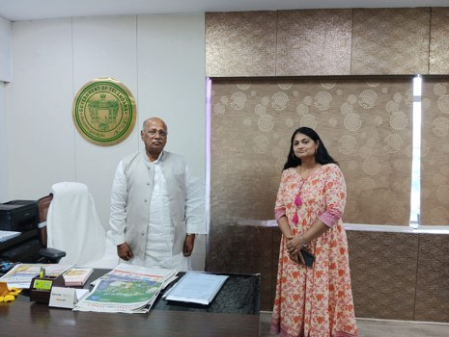
7 SEPTEMBER 2025

Meeting with Shri Charandas Mahant and Smt. Jyotsna Charandas Mahant, Raipur
Mercora International Founder and Managing Partner Mrs. Jaya Geetha Kiran Desaraju had a meeting with Honourable Shri Charandas Mahant, Leader of Opposition, Chhattisgarh, and Smt. Jyotsna Charandas Mahant, Honourable Member of Parliament for Korba Lok Sabha constituency, at their residence in Raipur.
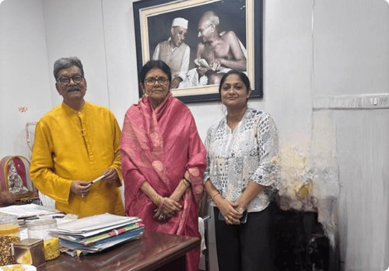
9–10 SEPTEMBER 2025

Viksit Bharat 2047: Indo-German Pathways towards Sustainable Agriculture and Food Systems
Mercora International Founder and Managing Partner Mrs. Jaya Geetha Kiran Desaraju and Ms. A. Manasa Raj participated in the conference on Viksit Bharat 2047 – Indo-German Pathways towards Sustainable Agriculture and Food Systems, and met senior officials, including Mr. Mehraj Ajij Shaikh, Deputy Commissioner, Ministry of Agriculture, and Mr. Navin Hura of GIZ.

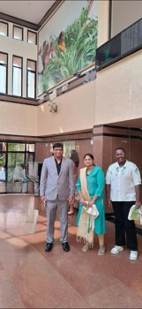  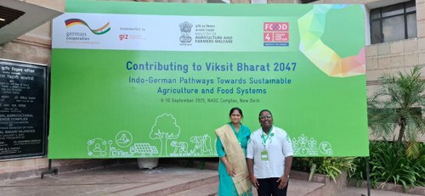 | 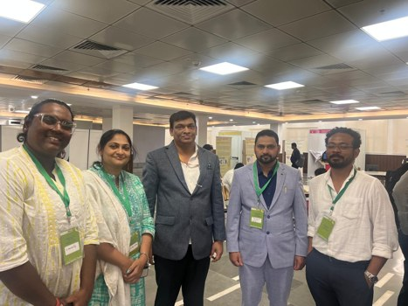  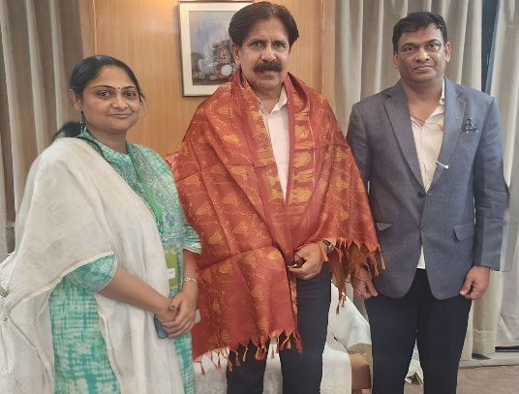  Shri. L.K. Atheeq (Retd. IAS), Additional Chief Secretary, Karnataka
15 SEPTEMBER 2025

Workshop on Catalysing Climate-Smart Agriculture: Building Alliances for the Future of Sustainable Rice
Mercora International Founder and Managing Partner Mrs. Jaya Geetha Kiran Desaraju attended the workshop on Catalysing Climate-Smart Agriculture: Building Alliances for the Future of Sustainable Rice, held in New Delhi.
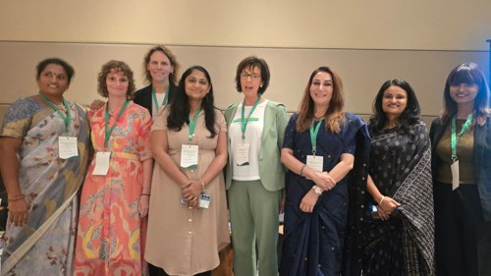 | 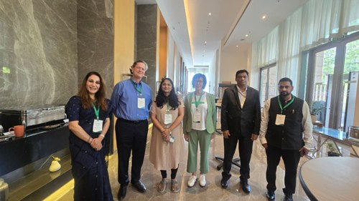
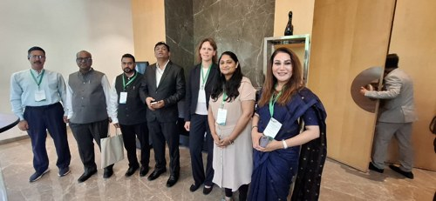 | 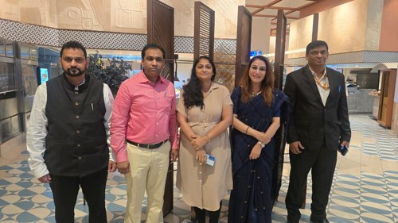
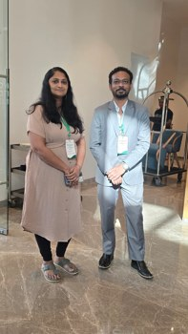 | 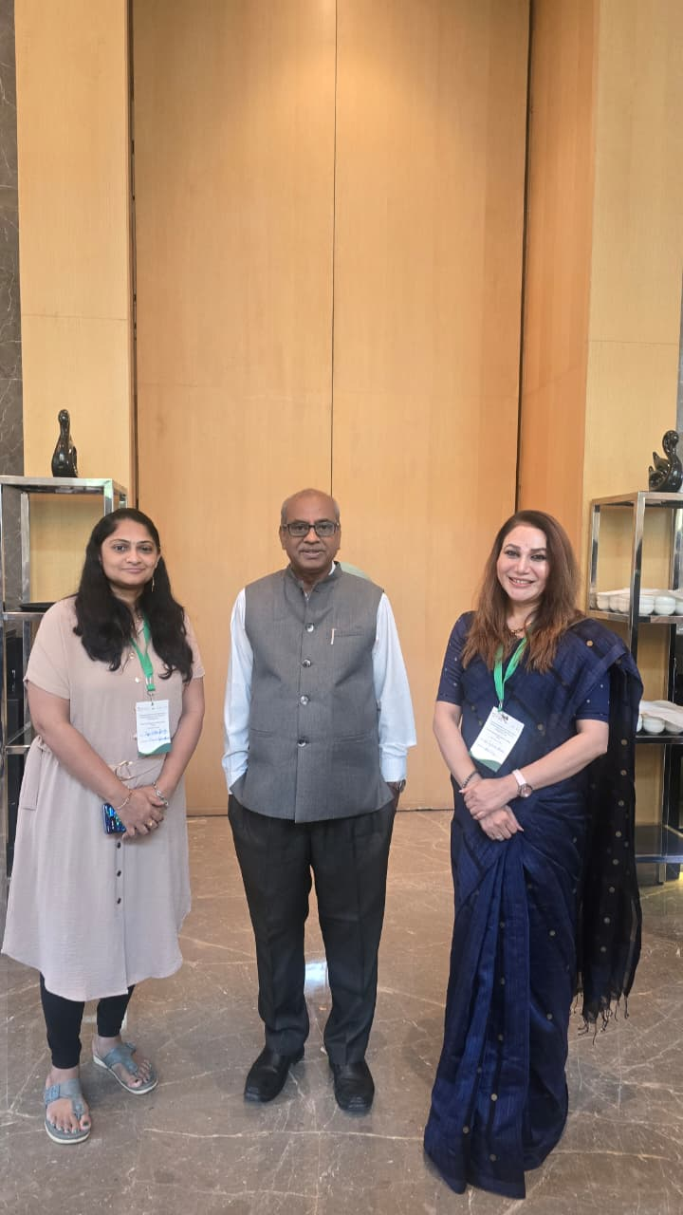
29 SEPTEMBER – 6 OCTOBER 2025

Native Araku Coffee, Araku Valley
Mercora International Founder and Managing Partner Mrs. Jaya Geetha Kiran Desaraju and Ms. A. Manasa Raj met Mr. Ram Kumar Varma, CEO, and Mrs. Sudhira of Native Araku Coffee during a visit to Araku Valley.
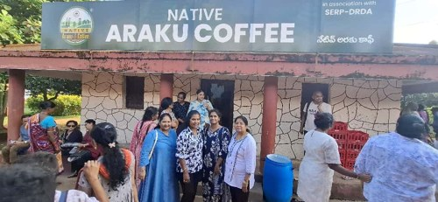 | 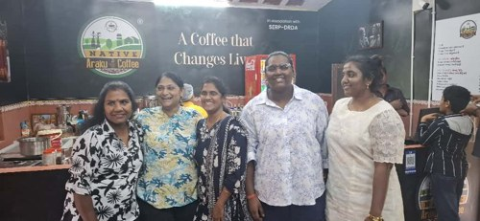
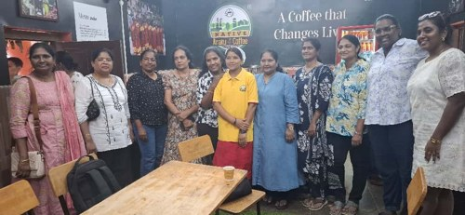 | 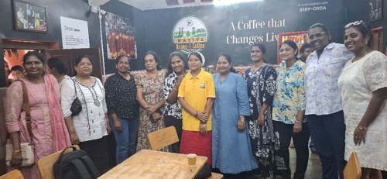
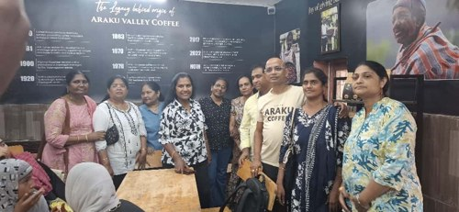 | 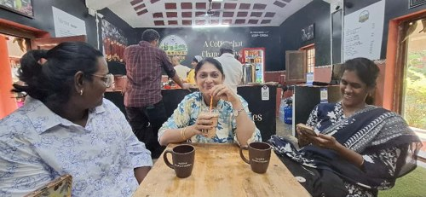
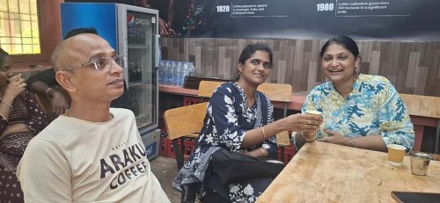 | 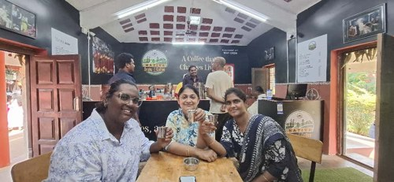
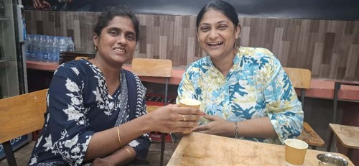
13 OCTOBER 2025

Collaboration with APTIT Solutions
Mercora International Founder and Managing Partner Mrs. Jaya Geetha Kiran Desaraju entered into a collaboration with M/s APTIT Solutions, Mr. V. P. Dadhirao Sridhar, Director.
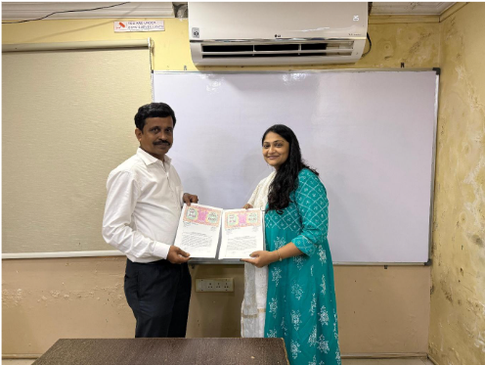
29 OCTOBER 2025

World Mental Health Day Seminar, India Islamic Cultural Centre
Mercora International attended the seminar on Wellness and Health, organised by the Wellness & Health Committee of the India Islamic Cultural Centre in collaboration with NFH to mark World Mental Health Day, conducted by Mrs. Nidha Jawar.
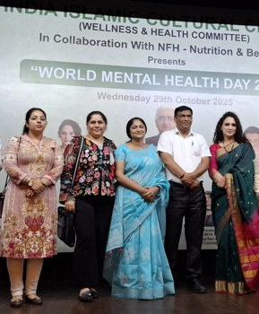
6–7 NOVEMBER 2025

National Workshop on Future Farming: Leveraging Carbon Markets (Asian Development Bank)
Mercora International Founder and Managing Partner Mrs. Jaya Geetha Kiran Desaraju and Ms. A., Manasa Raj attended the two-day workshop on Future Farming – Leveraging Carbon Markets, conducted by the Asian Development Bank (ADB) in New Delhi.
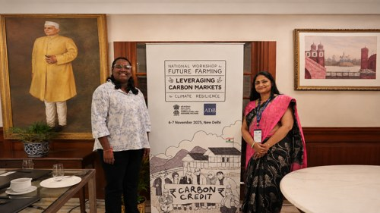 | 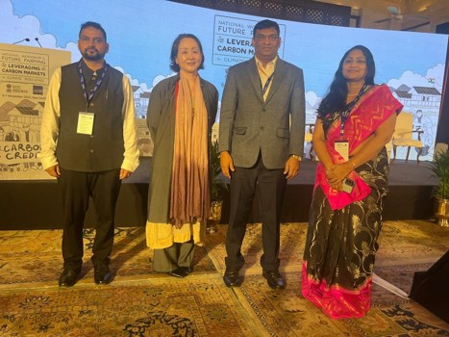
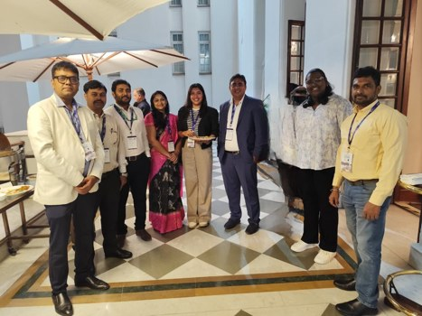 | 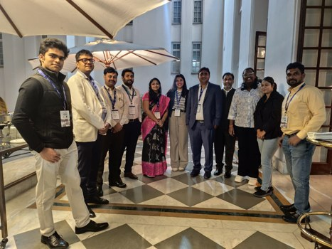
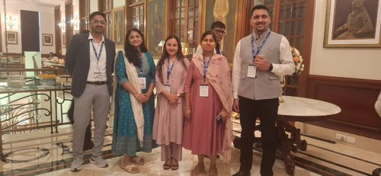 | 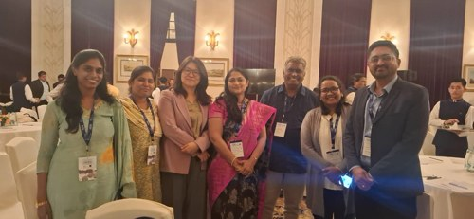
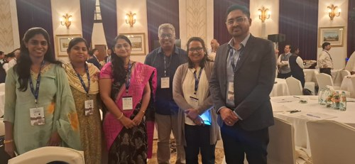 | 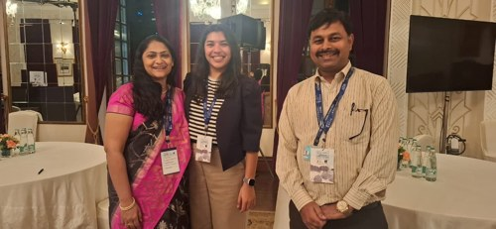
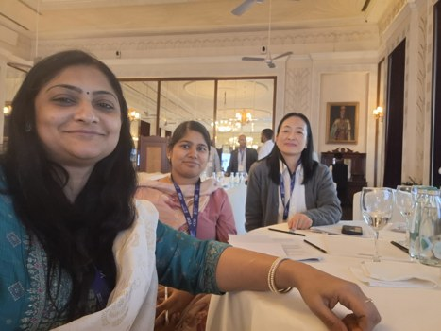 | 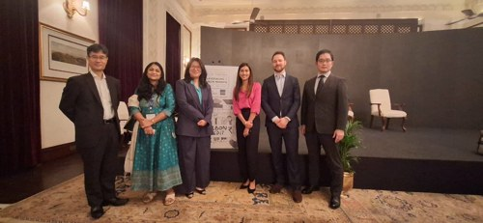
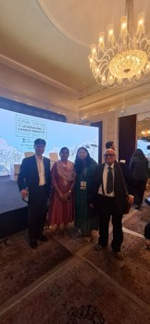 | 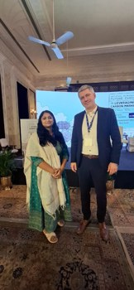
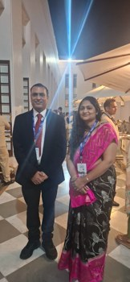 | 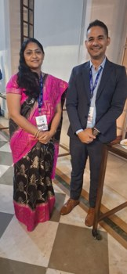
2 DECEMBER 2025

Collaboration with RishiPal
Mercora International Founder and Managing Partner Mrs. Jaya Geetha Kiran Desaraju entered into a collaboration with Rishipal Gupta and Sons Pvt ltd, Mr. Ankur Gupta, Managing Director.
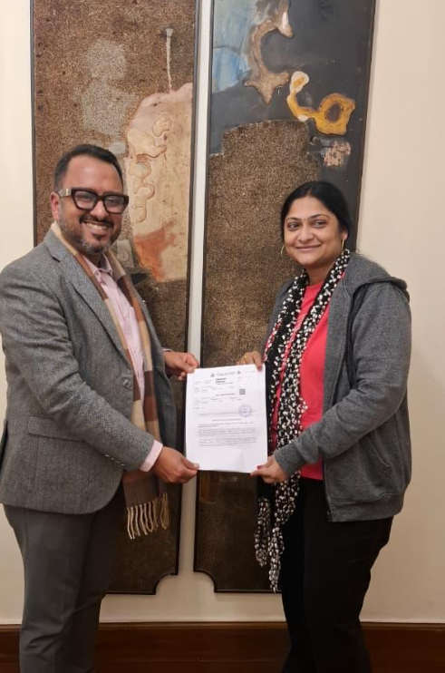 | 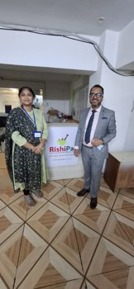


2026
28–29 JANUARY 2026

National IP Yatra 2026, ICRISAT, Hyderabad
Mercora International Founder and Managing Partner Mrs. Jaya Geetha Kiran Desaraju participated in National IP Yatra 2026 at ICRISAT, Hyderabad. Met Dr. Himanshu Pathak, Director General, ICRISAT, and Shri C.S.S. Rao, Joint Director & Head of Office, MSME-Development and Facilitation Office (MSME-DFO), Hyderabad, Ministry of MSME, Government of India, Dr Stanford Blade Deputy Director General – Research and Innovation and Dr Dinesh Kumar Chauhan Head - Agribusiness and Innovation Platform
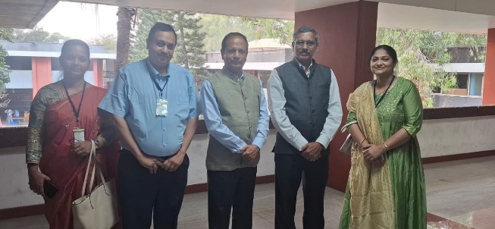  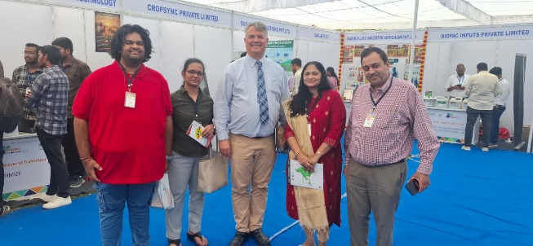 | 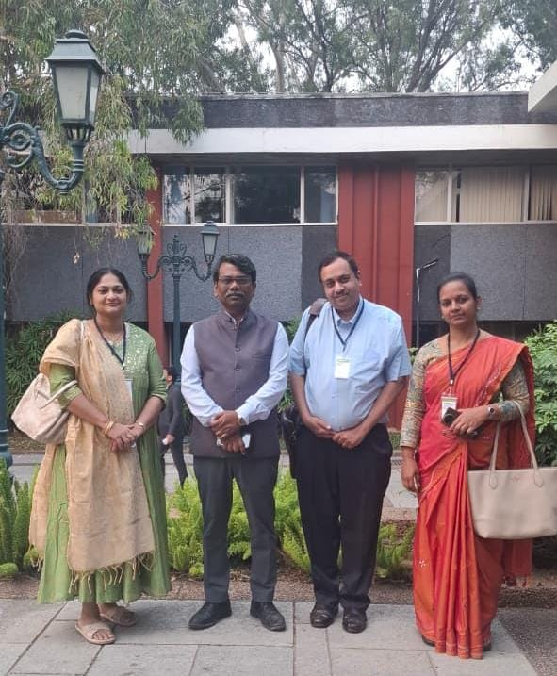
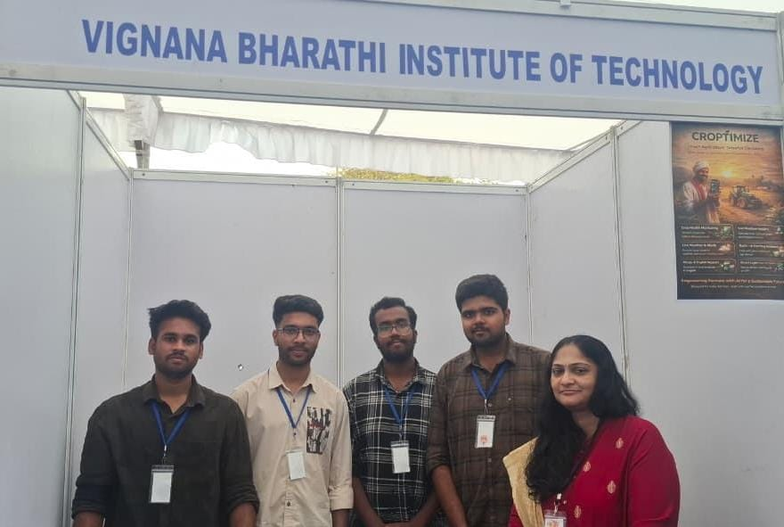 | 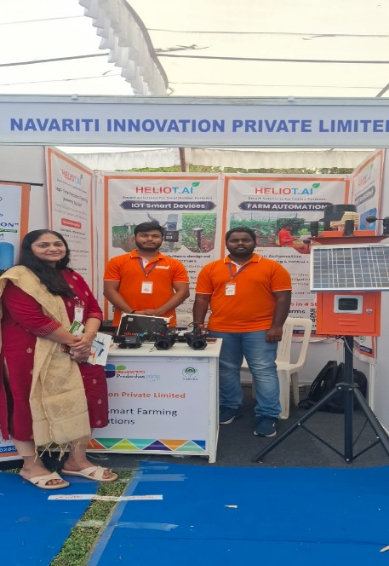
31 JANUARY 2026

Collaboration with Native Araku Coffee
Mercora International Founder and Managing Partner Mrs. Jaya Geetha Kiran Desaraju entered into a collaboration with Native Araku Coffee. Present: Mr. Ram Kumar Varma, CEO.
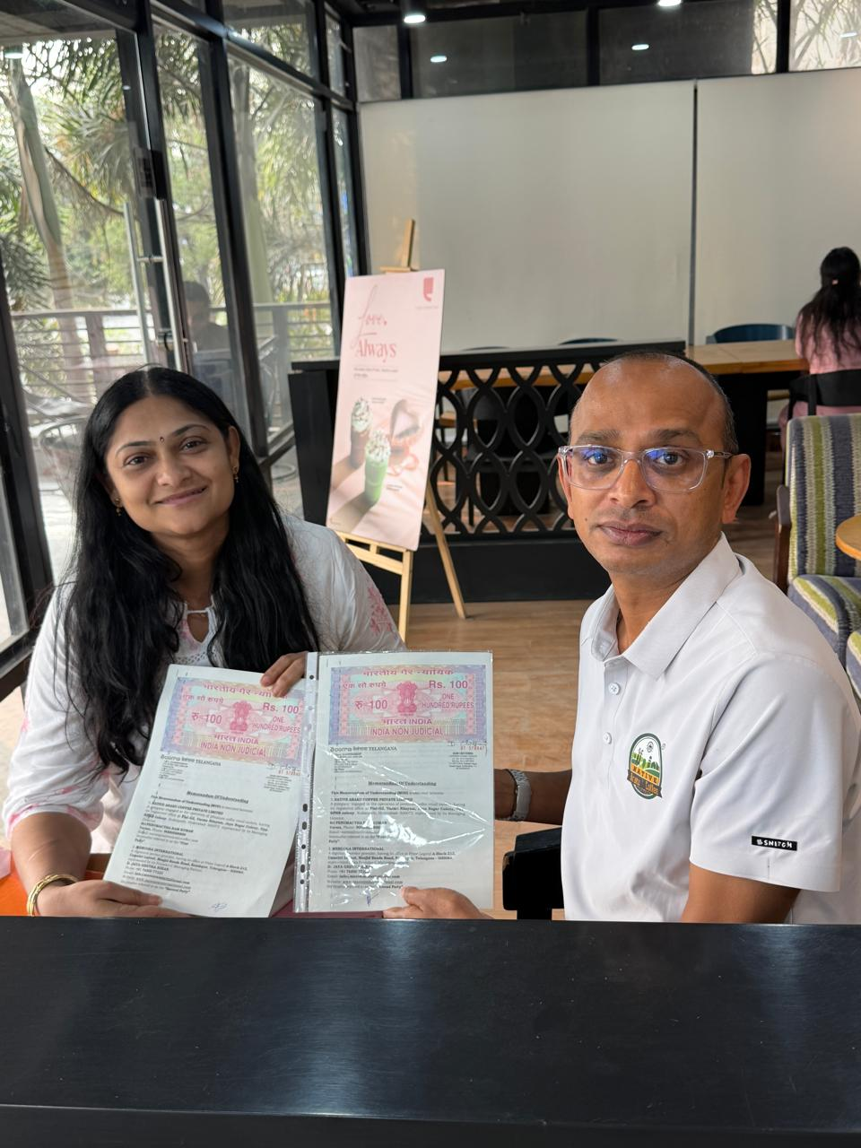
FEBRUARY 2026

Meeting with Honourable Vemireddy Prabhakar Reddy
Mercora International Founder and Managing Partner Mrs. Jaya Geetha Kiran Desaraju had a meeting with our Honourable Member of Parliament Shri. Vemireddy Prabhakar Reddy.
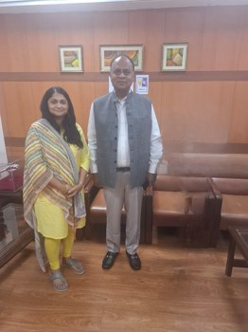
FEBRUARY 2026

India AI Impact Summit 2026, New Delhi
Mercora International Founder and Managing Partner Mrs. Jaya Geetha Kiran Desaraju participated in the India AI Impact Summit 2026 at Bharat Mandapam, New Delhi.
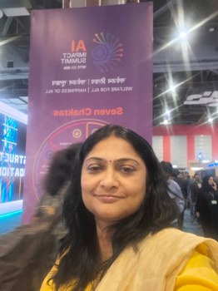 | 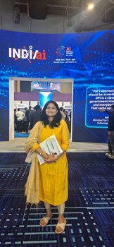
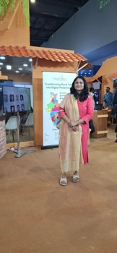 | 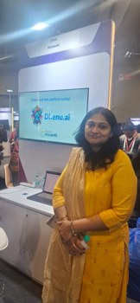
 | 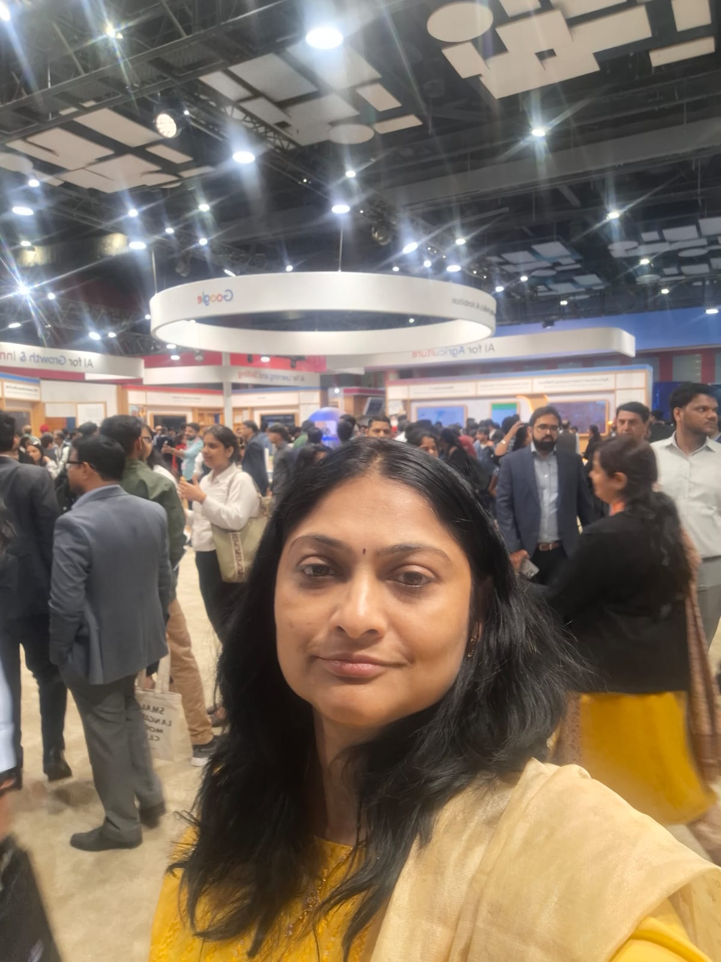
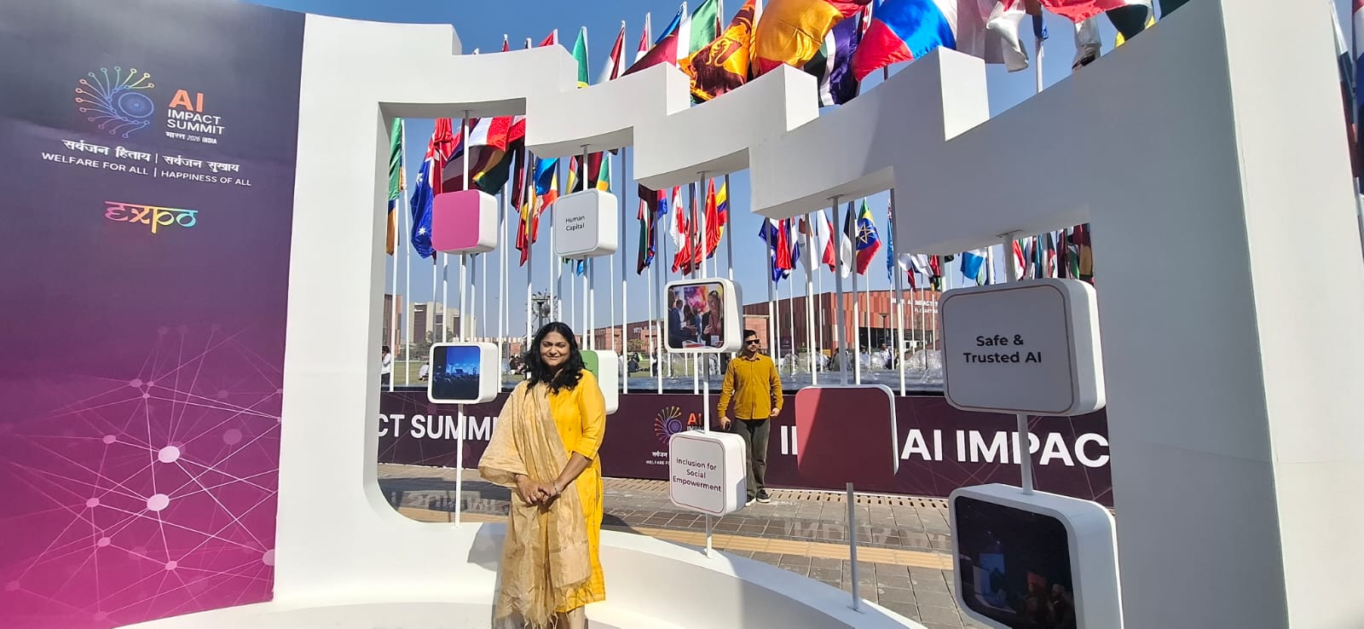 | 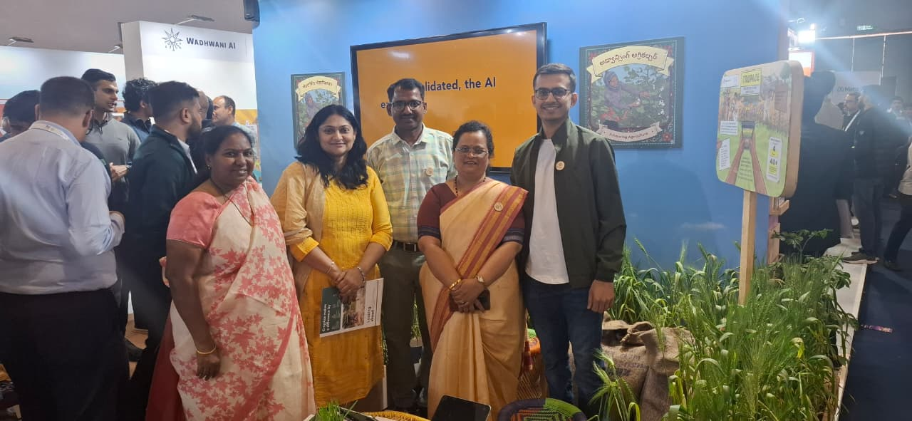
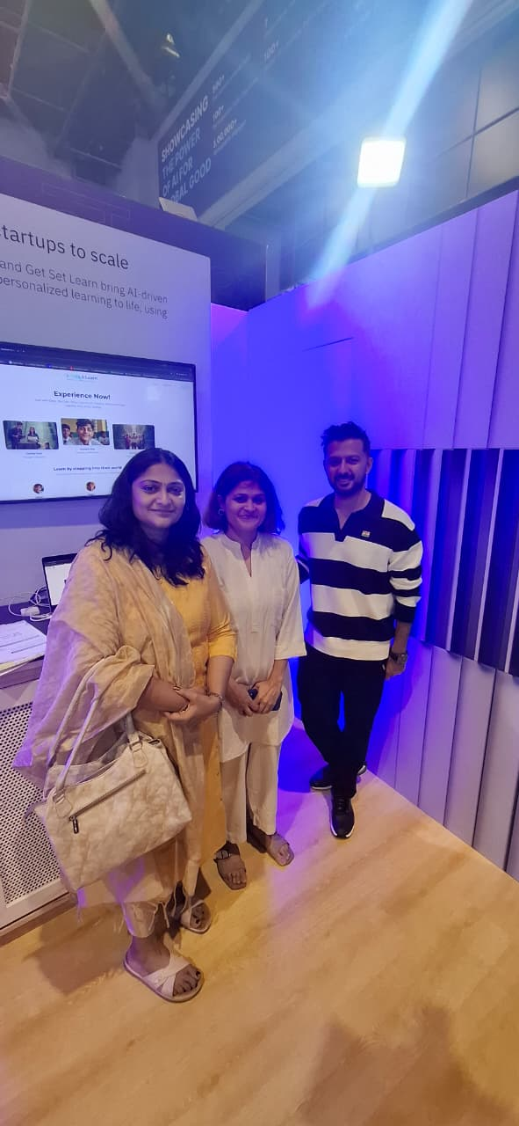
19–21 FEBRUARY 2026

MSME Tech Connect 2026
Mercora International Founder and Managing Partner Mrs. Jaya Geetha Kiran Desaraju participated in MSME Tech Connect 2026.
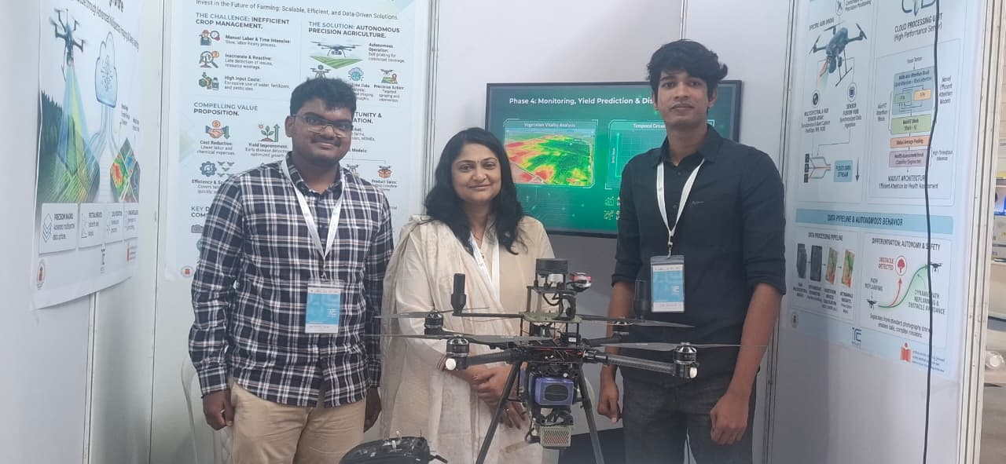 | 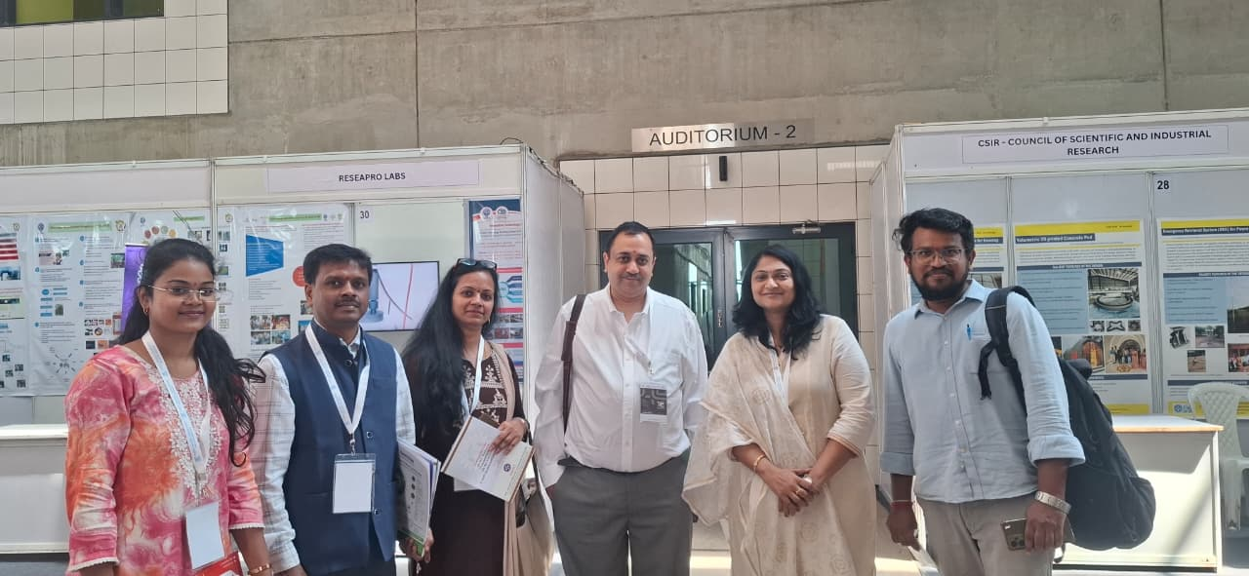
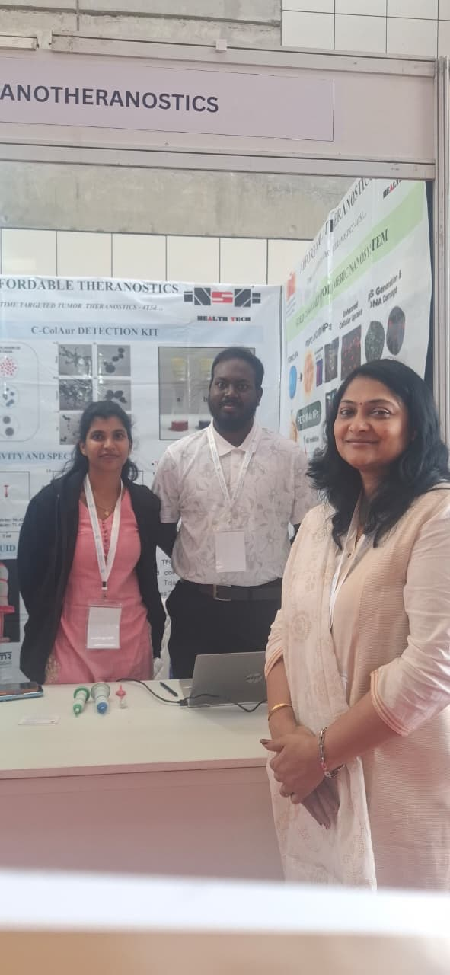 | 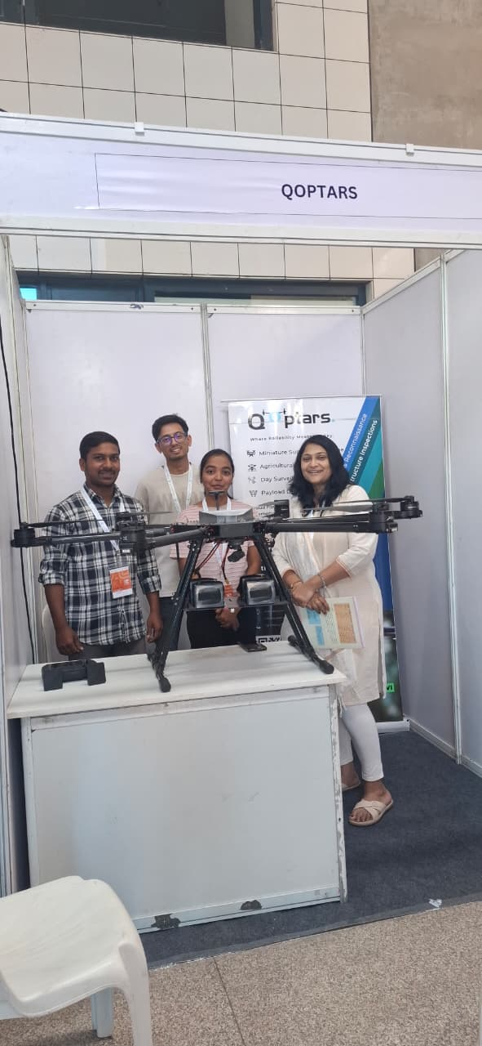
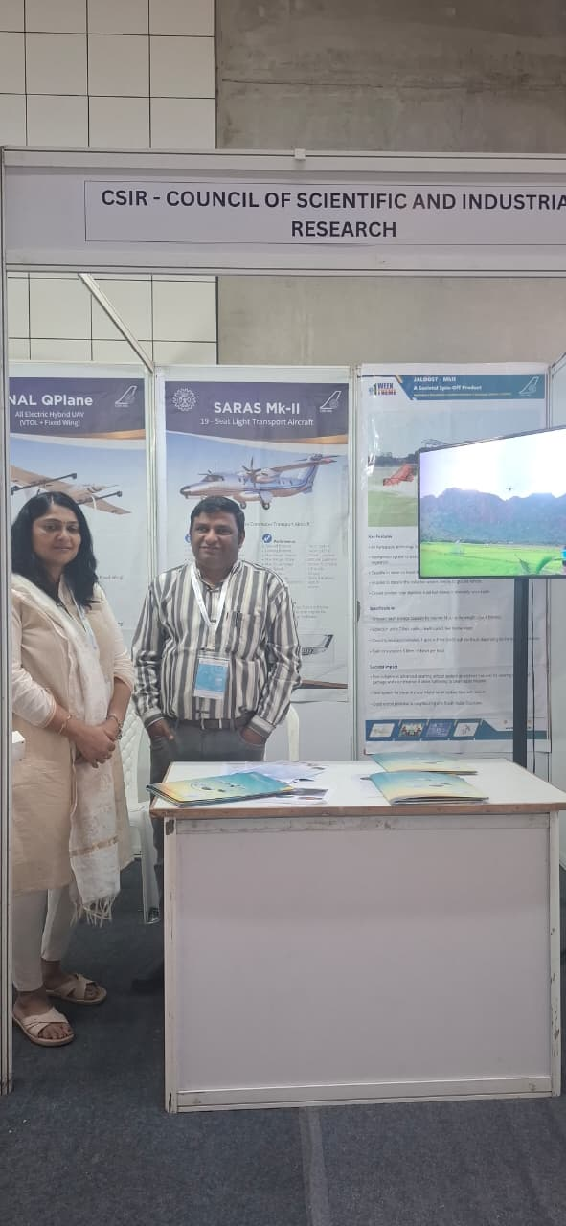 | 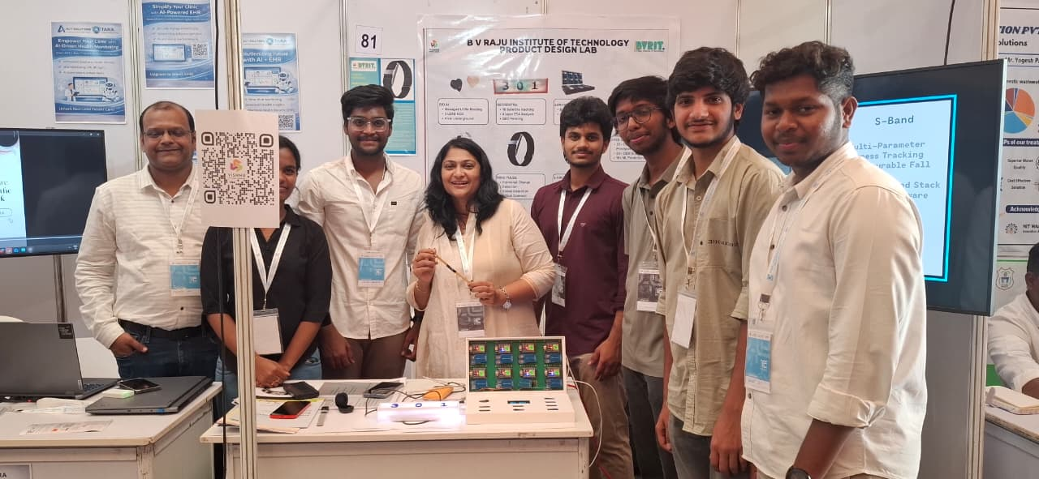
4 MAY 2026

Collaboration with Tridantor Ideaus Pvt Ltd
Mercora International Founder and Managing Partner Mrs. Jaya Geetha Kiran Desaraju entered into a collaboration with Tridantor Ideaus Pvt Ltd. Present: Mr. R.V. Ramakrishna, Founder and CEO.
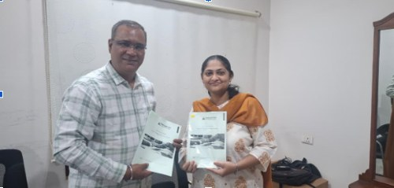 | 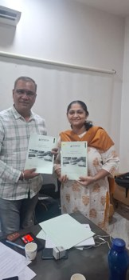
6 MAY 2026

Collaboration with Arisetty Technologies Private Limited
Mercora International Founder and Managing Partner Mrs. Jaya Geetha Kiran Desaraju entered into a collaboration with Arisetty Technologies Private Limited. Present: Mr. Ravi Arisetty, Founder, and Mr. C.J. Babu, Chief Business Officer.
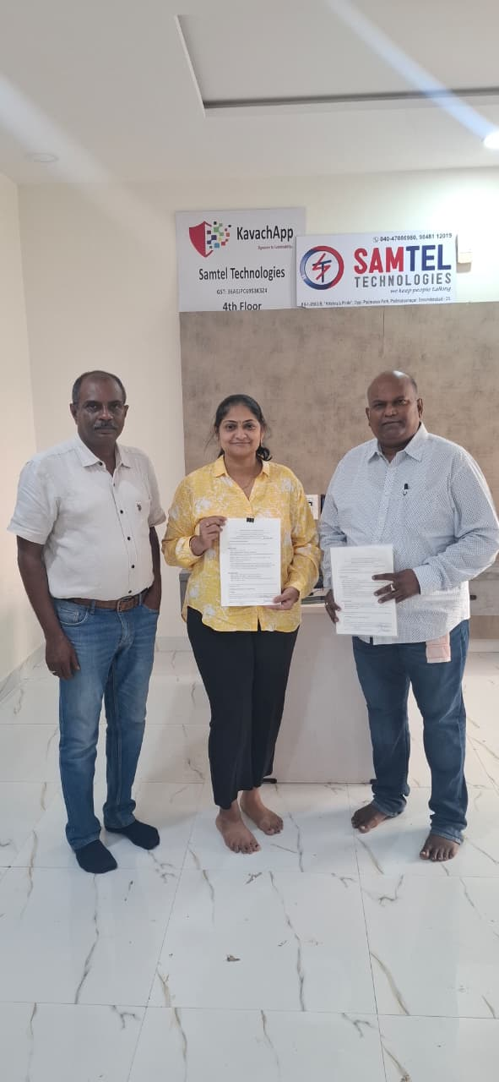
29 MAY 2026

Meeting with Chamadia Group
Mercora International Founder and Managing Partner Mrs. Jaya Geetha Kiran Desaraju met Mr. Ravikanth Chamadia and Mr. Sparch Chamadia of the Chamadia Group in Pune
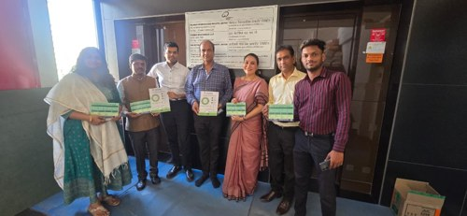 | 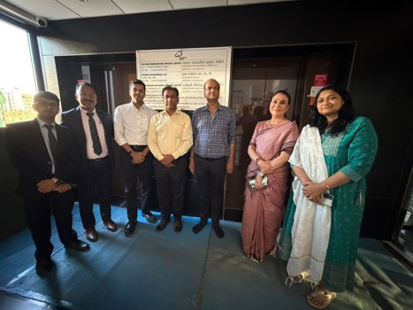
29 MAY 2026

Meeting with World Trade Center Pune
Mercora International Founder and Managing Partner Mrs. Jaya Geetha Kiran Desaraju met Mr. Nhiraj Khinvasara, Executive Director, World Trade Center Pune.
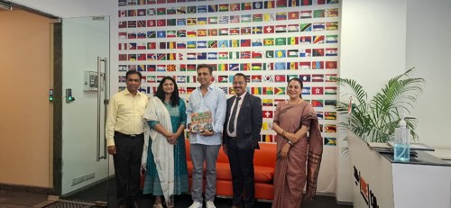 | 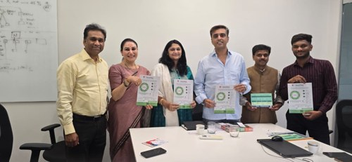
3 JUNE 2026

Meeting with Mr. Vipin Kumar, Vishwa Hindi Parishad
Mercora International Founder and Managing Partner Mrs. Jaya Geetha Kiran Desaraju met Mr. Vipin Kumar of the Vishwa Hindi Parishad.
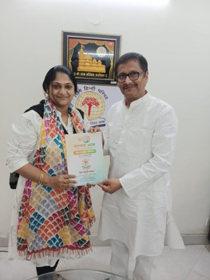
25 JULY 2026

Launch of CLIQIN – Integrated Healthcare, Insurance and AI Platform
Mrs. Jaya Geetha Kiran Desaraju, Founder & Managing Partner of Mercora International, was honoured to attend the launch of CLIQIN, an innovative integrated platform that brings together healthcare, insurance and artificial intelligence to transform digital healthcare.
She congratulated Mr. Vamshi, Mr. Prasanna and the entire CLIQIN team, and wished them great success in building a more accessible, intelligent and patient-centric healthcare ecosystem.
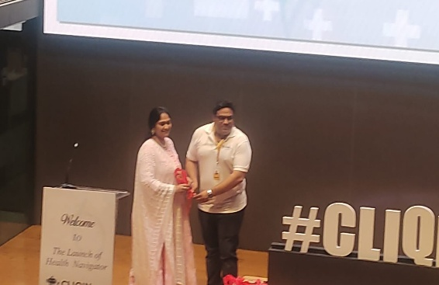  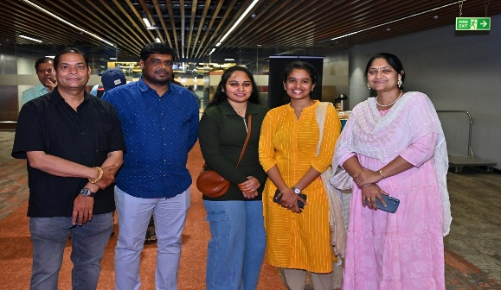 | 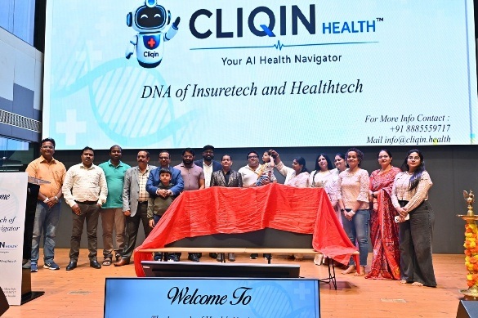  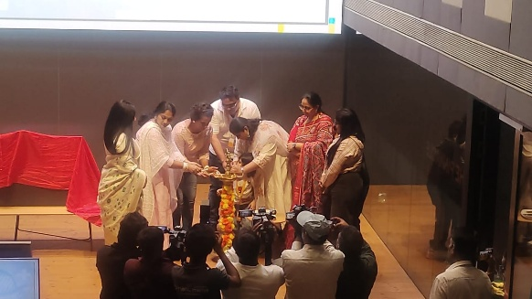
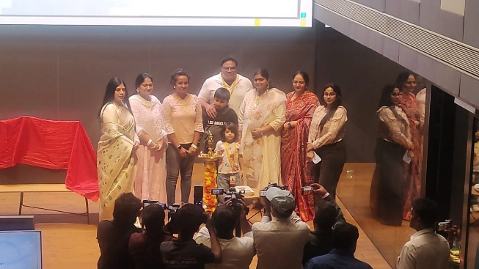 | 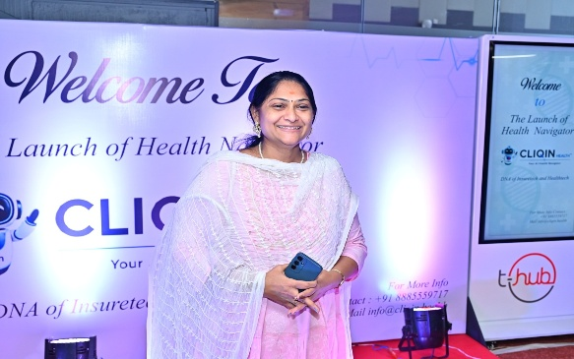
8 AUGUST 2026

Chief Guest and Project Evaluator, IdeaVerse 2026
Mrs. Jaya Geetha Kiran Desaraju, Founder & Managing Partner of Mercora International, was honoured to serve as Chief Guest and Project Evaluator at IdeaVerse 2026 at Vignan Bharathi Institute of Technology.
She appreciated the creativity and innovation of the student participants, and thanked the management, Principal, faculty, coordinators and Team ALGOVEDHA for their warm hospitality, extending her best wishes to all the student innovators.
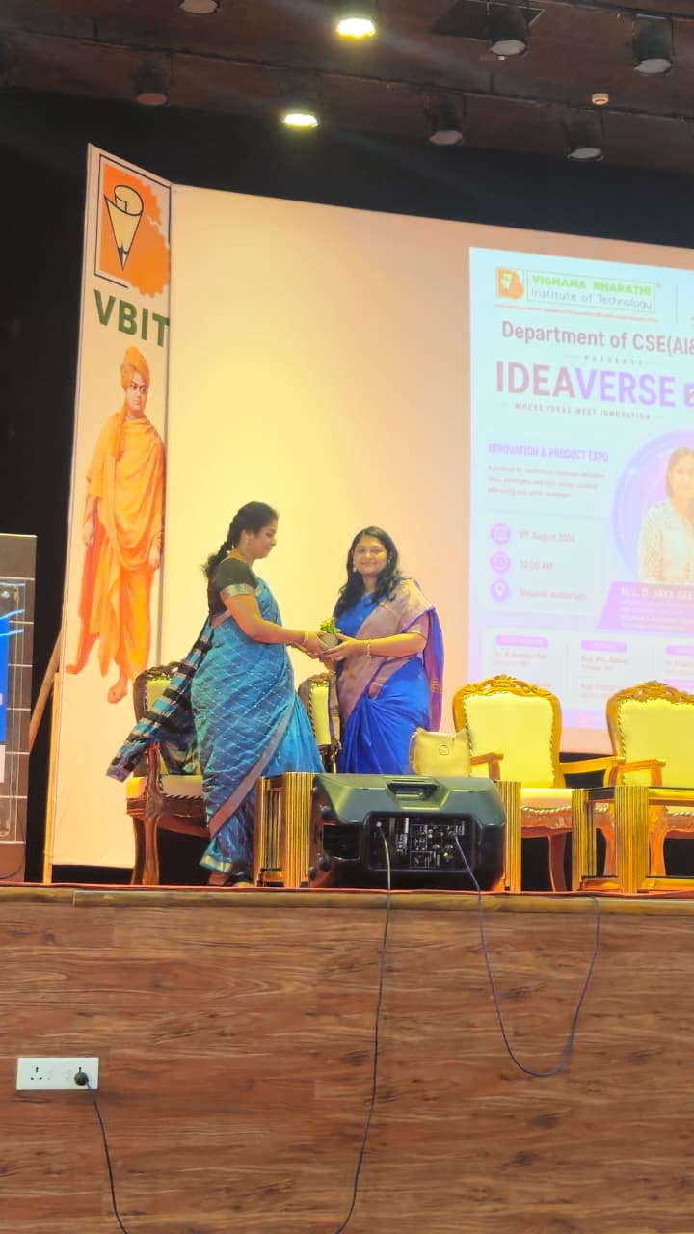 | 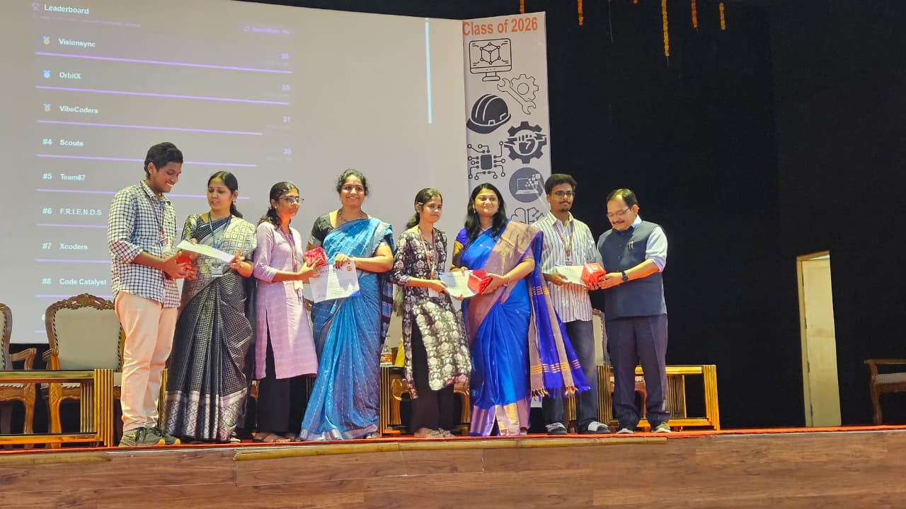
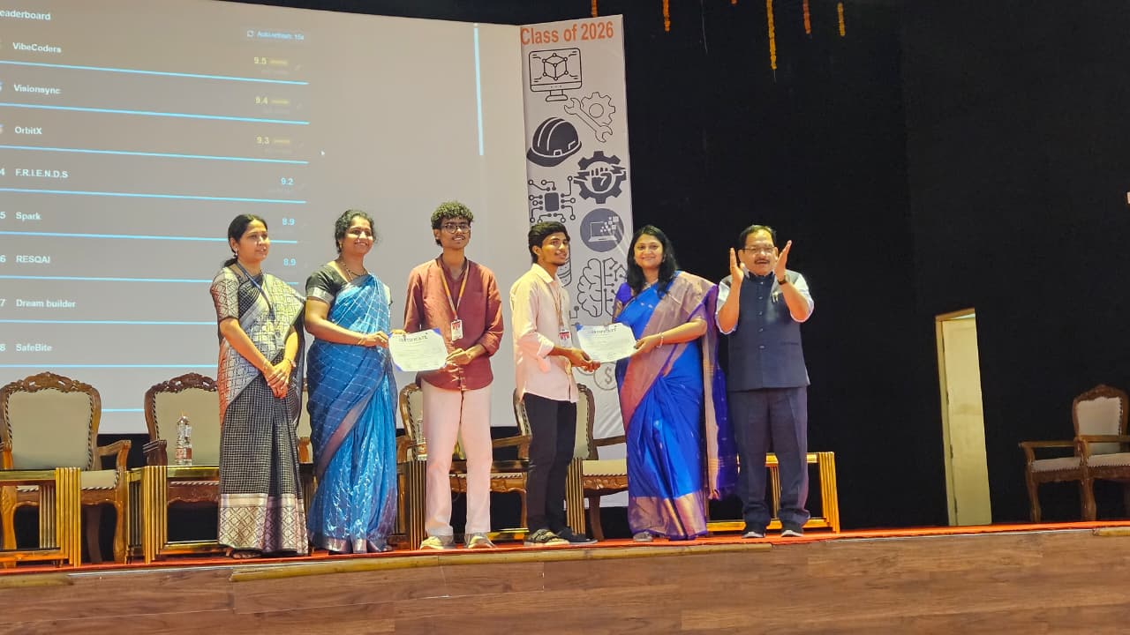 | 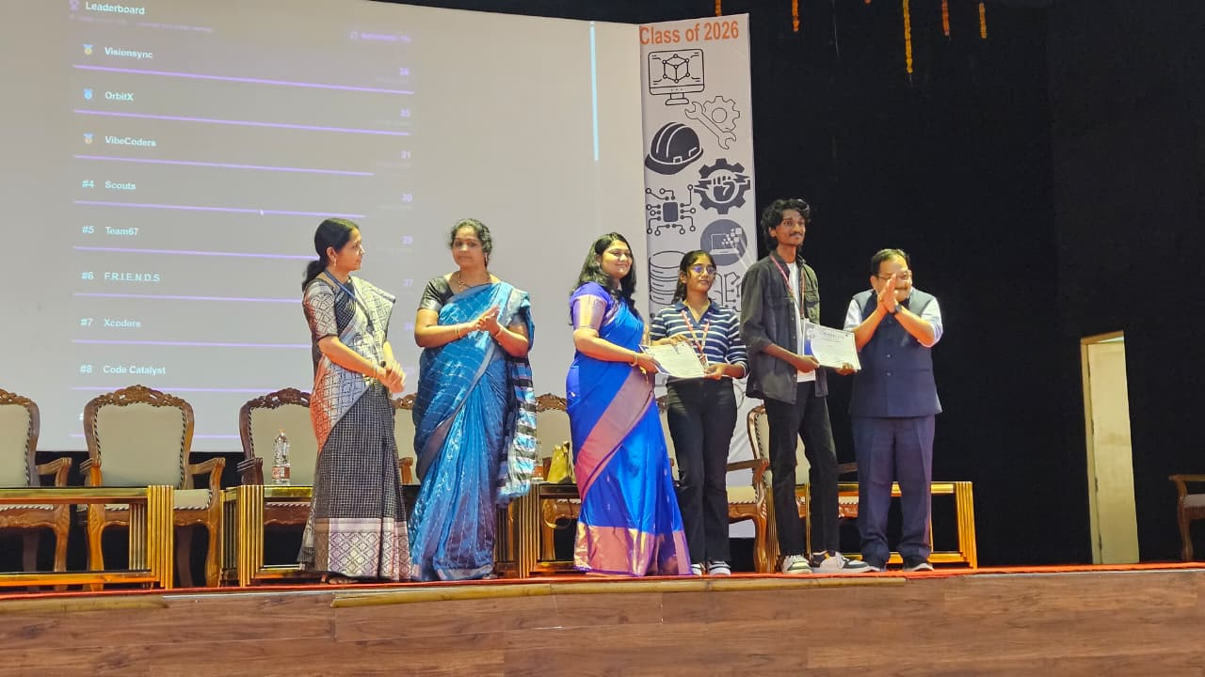
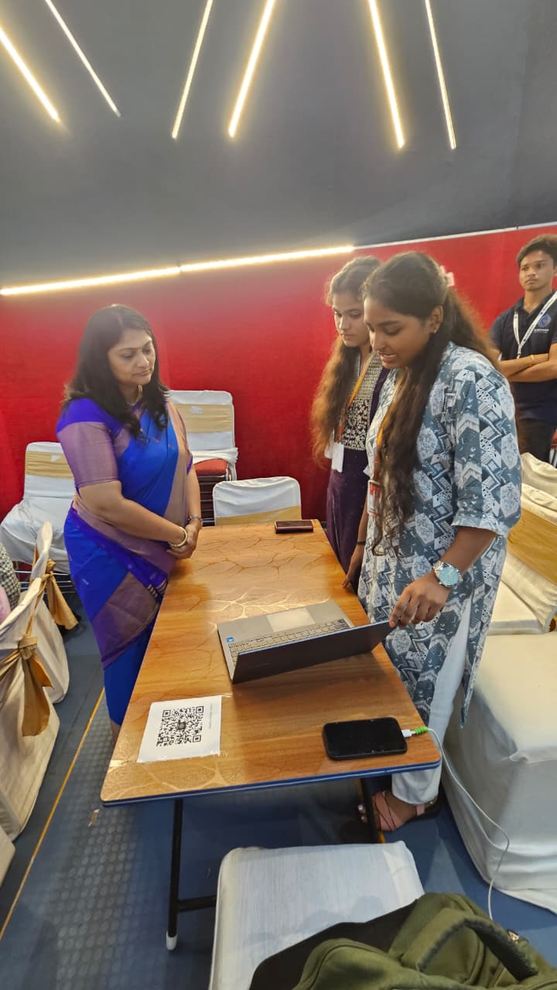 | 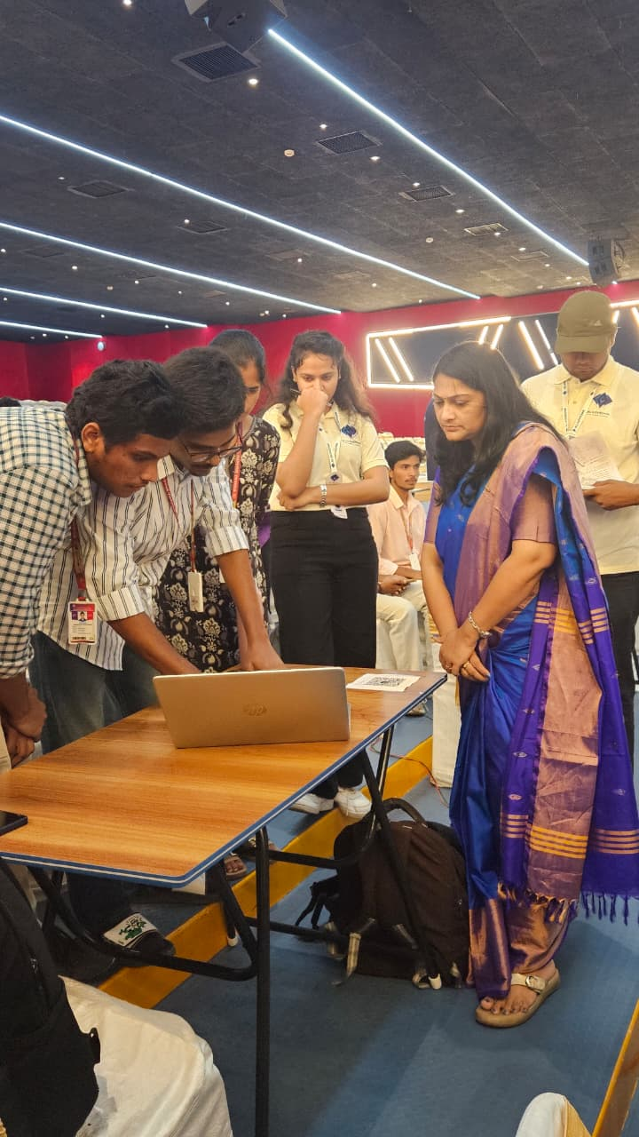
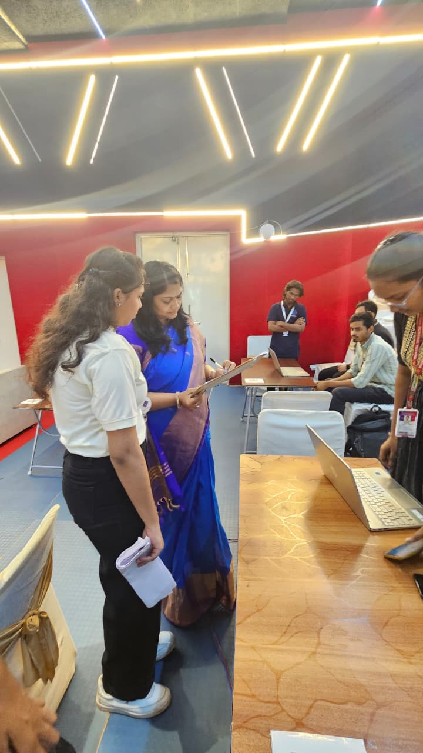
17 OCTOBER 2026

Recognised as a Promising Startup – AIC ALEAP WE-Hub Accelerator Programme
A proud milestone for Mercora International!
Founder & Managing Partner, Mrs. D. Jaya Geetha Kiran, was honoured to be recognised as a promising startup under the AIC ALEAP WE-Hub Accelerator Programme, supported by Atal Innovation Mission (AIM), NITI Aayog, Government of India. This milestone was shared in the esteemed presence of Smt. Rama Devi Kanneganti, President, and Dr. Zahoorullah S. M., Chief Innovation Officer, AIC ALEAP WE-Hub. A meaningful step forward in our journey of innovation and impact!
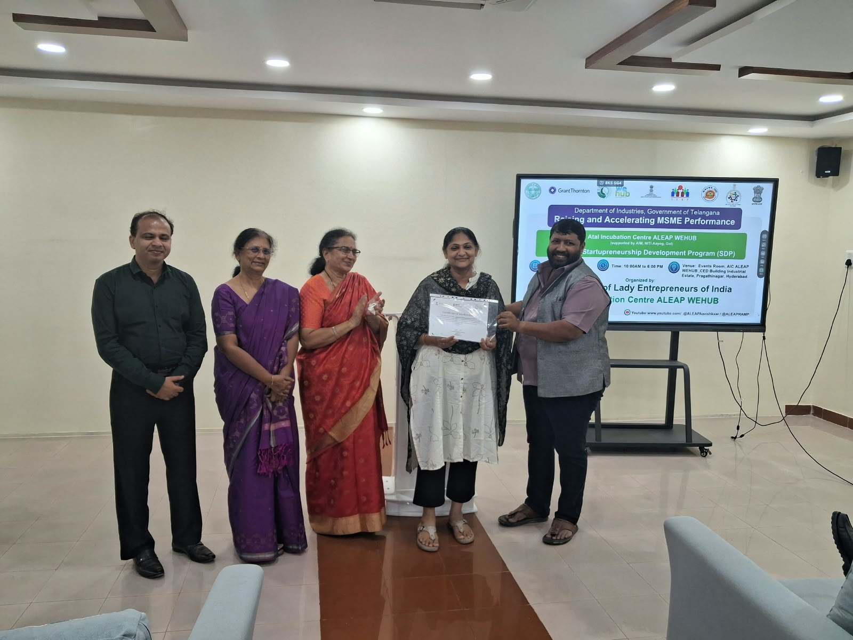
20 OCTOBER 2026

Meeting with Prof. (Dr.) Ramakant Dwivedi, India Central Asia Foundation
Mercora International Founder and Manging was honoured to meet Prof. (Dr.) Ramakant Dwivedi, Director, India Central Asia Foundation, and former OSD to the National Security Advisor, PMO, Government of India. Mercora looks forward to promoting entrepreneurship, building business collaborations and strengthening economic ties between India and Central Asia. Also had a meeting with Mr. Yogesh Kumar, Founder & CEO of QuantYogi Digital LLC, General Director Akacorp Global Tech Akasoft.
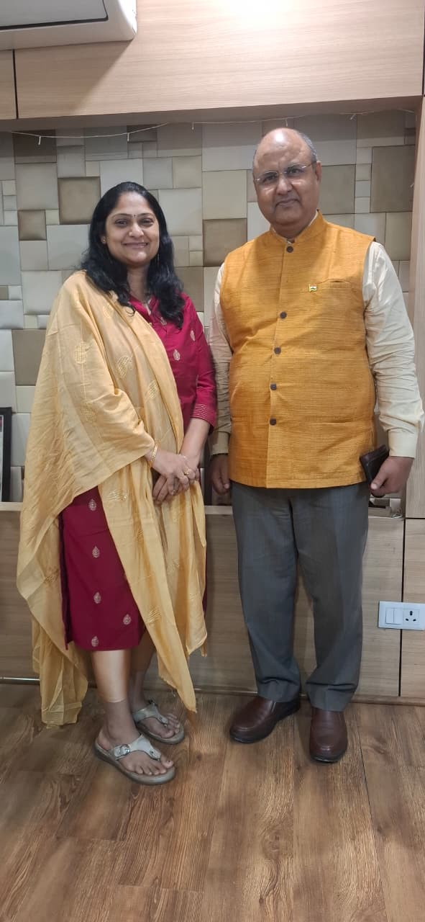 | 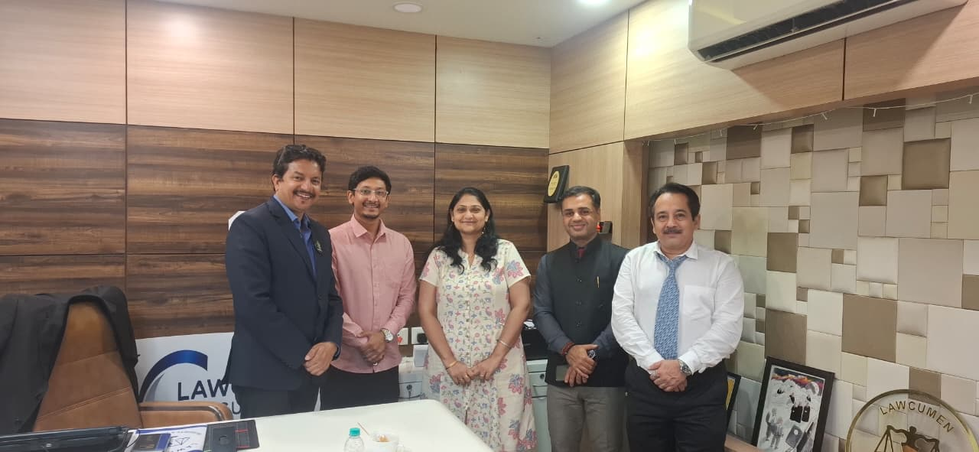

More highlights

Bathukamma Celebrations, Andhra Association, New Delhi in January 2026
Mercora International participated in the Bathukamma celebrations organised by the Andhra Association, New Delhi.
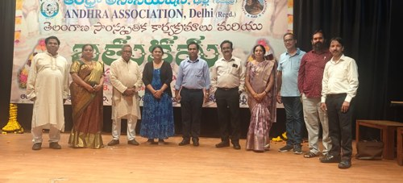

Diwali Milan, India Islamic Cultural Centre in October 2025
Mercora International participated in the Diwali Milan at the India Islamic Cultural Centre, meeting Mr. Salman Khurshid, President of the Centre, and former President Mr. Sirajuddin Qureshi.
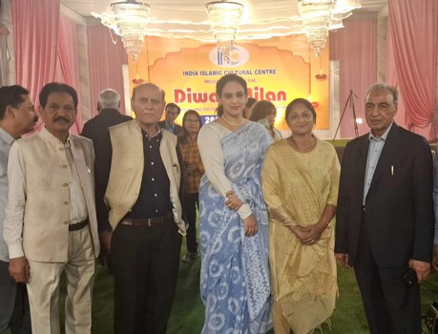 | 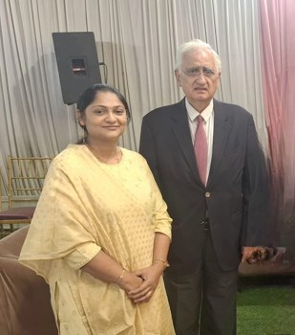

World Food Festival 2026
Mercora International attended the World Food Festival in January 2026.
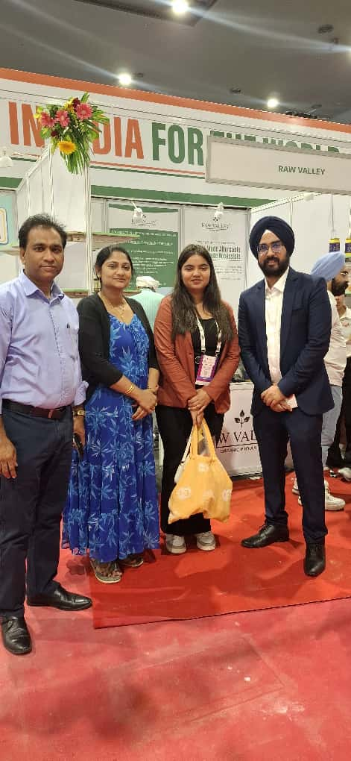 | 

